Key Concept Questions:
1) What does it mean for two figures to be congruent?
2) What does it mean for two figures to be similar?
3) What is true about the ratio of corresponding sides in similar triangles?
4) What is the “scale factor” of a pair of similar triangles?
5) How are the areas of similar triangles related?
6) What are the sine, cosine, and tangent ratios? What is the acronym we use to remember how they are defined?
7) Under what conditions can you use the Pythagorean Theorem, and the 3 primary trigonometric ratios to solve a triangle?
8) Under what conditions can you use the Sine Law to solve a triangle?
9) Under what conditions can you use the Cosine Law to solve a triangle?

Text Questions: This list of questions is not meant to overwhelm you, it is meant to give you as much resources as possible to practice what we learned this unit. Completing as many as you can will ensure you are ready for the test on Tuesday.
p. 386 #1-5, 9-23
p. 430 #1-12

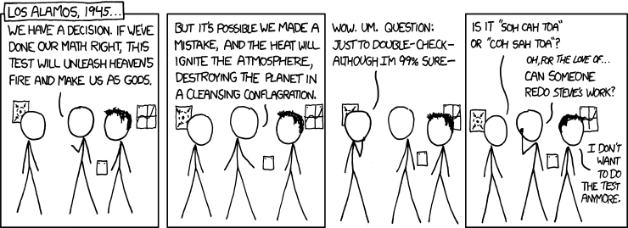
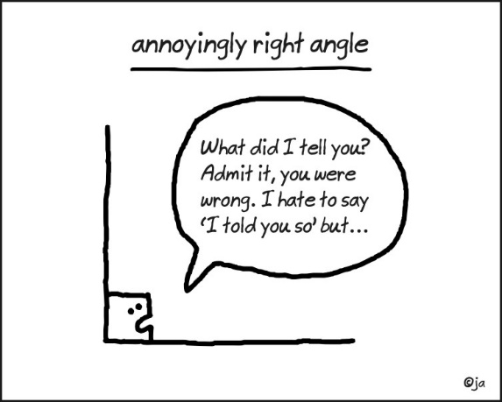
If you do finish all of this, Mr. Smith can provide you with more.

