When you are done this course, you won’t have a TI-Nspire with you. If you want to use a finance solver, you will need to use on online. On your phone or on a chromebook, head over to the following site (or snapchat the QR code).

http://www.zenwealth.com/businessfinanceonline/TVM/TVMCalcWindow.html

It looks like this!
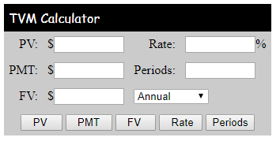

It works the same as the Nspire, but instead of entering a value for CpY and PpY, you select the appropriate choice from a drop down menu.

In this task, you will solve 5 problems typical to what we do in class, but you will use the online solver instead. As usual, fill in your screens on the handout.

First, try this one to get started:

Example: Mr. Smith puts away $200 per month into an account that pays 4.5% interest compounded monthly for 20 years. How much will he have after 20 years?

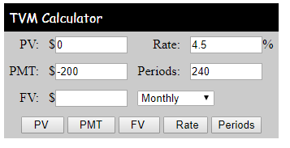
a) Copy the following into your online solver:

b) Click “FV” to solve for FV

If you got $77,624.87 then you are ready to use the online solver on your own!

Write a brief concluding statement for each question in the blank space provided.

1) Mr. and Mrs. Smith started saving $25 per month for when Bryden was done high school. The money was invested in a TFSA (tax free savings account) that paid 5.4% interest compounded monthly. How much will Bryden have in 18 years (FV)?

2) Mrs. Smith bought a new diaper bag online for $99. She put in on her credit card (which has a rate of 19% compounded monthly). She plans to make a minimum monthly payment of $10. How many months will it take to pay off?

3) Mr. Smith bought a 2010 Volkswagen Golf Wagon for $16,500 five years ago. He agreed to pay it back in monthly payments at an interest rate of 3.9%. Calculate his monthly payment.
4) Mr. Smith sees a payday loan advertisement driving home one day. It says “borrow $500 for only $25”. This means you borrow the $500, and pay back $525 on your payday (1 week from now). What is the effective yearly interest rate of this loan?

5) When Bort retires, he wants to be able to withdraw $1,000 every week for the rest of his life (30 years we’ll say). If he can invest at 5% compounded weekly, how much must he have saved up for retirement (PV)?

