Name: __________________________________ Due Date: __________________________
/30

You may complete this assignment on these pages, but if you want to use separate pieces of paper, that is OK. For full marks:

- Identify the 3D shape you are working with in the blank.
- Write down the formula you are using.
- Include units in your final answer, and put a box around it

- Calculate the volume of each figure. each.
a) Shape: ____________________ b) Shape: ____________________
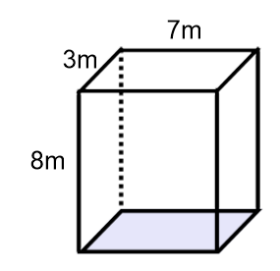
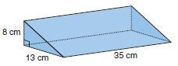

c) Shape: ____________________ d) Shape: ____________________
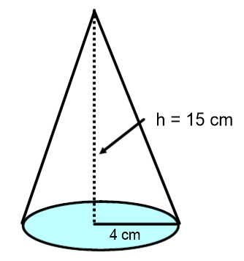
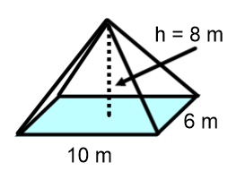

e) Shape: _____________________________

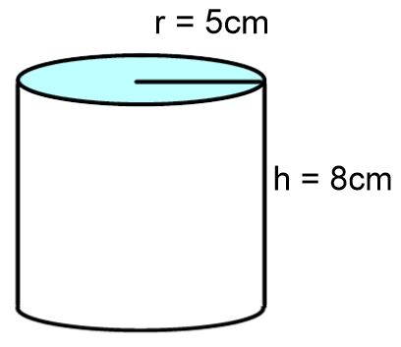

2) Find the volume of the following cone. You will need to determine the height first using the Pythagorean Theorem.

3) You are at the store buying an iced tea for yourself. You have two choices illustrated below. They each cost $3, so you want to buy the one with the largest volume.

Which will you buy? Explain your choice fully.

Option 1: Arizona Tea Option 2: Peace Tea
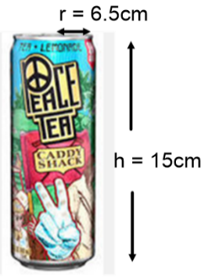
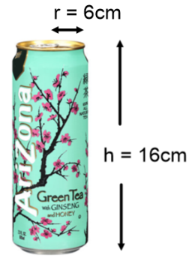

4) The following steps will help you find the volume of the prism given below:
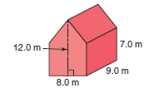

a) Find the area of the pentagon base. Mr. Smith has redrawn it for you below. Hint: The pentagon base is made up of a rectangle, with a triangle sitting on top of it!
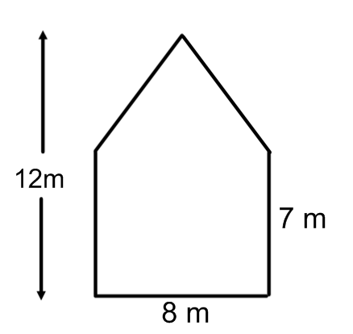

b) Use $V=A_{base}×height$ to find the volume of the prism.

